***FLOOD MONITORING AND EARLY WARNING SYSTEM***

**Phase 5 submission document**

**PROJECT TITLE:Flood monitoring**

**PHASE 5: Project documentation and submission**

**TOPIC: In this section we will document the complete**

**project and prepare it for submission.**

[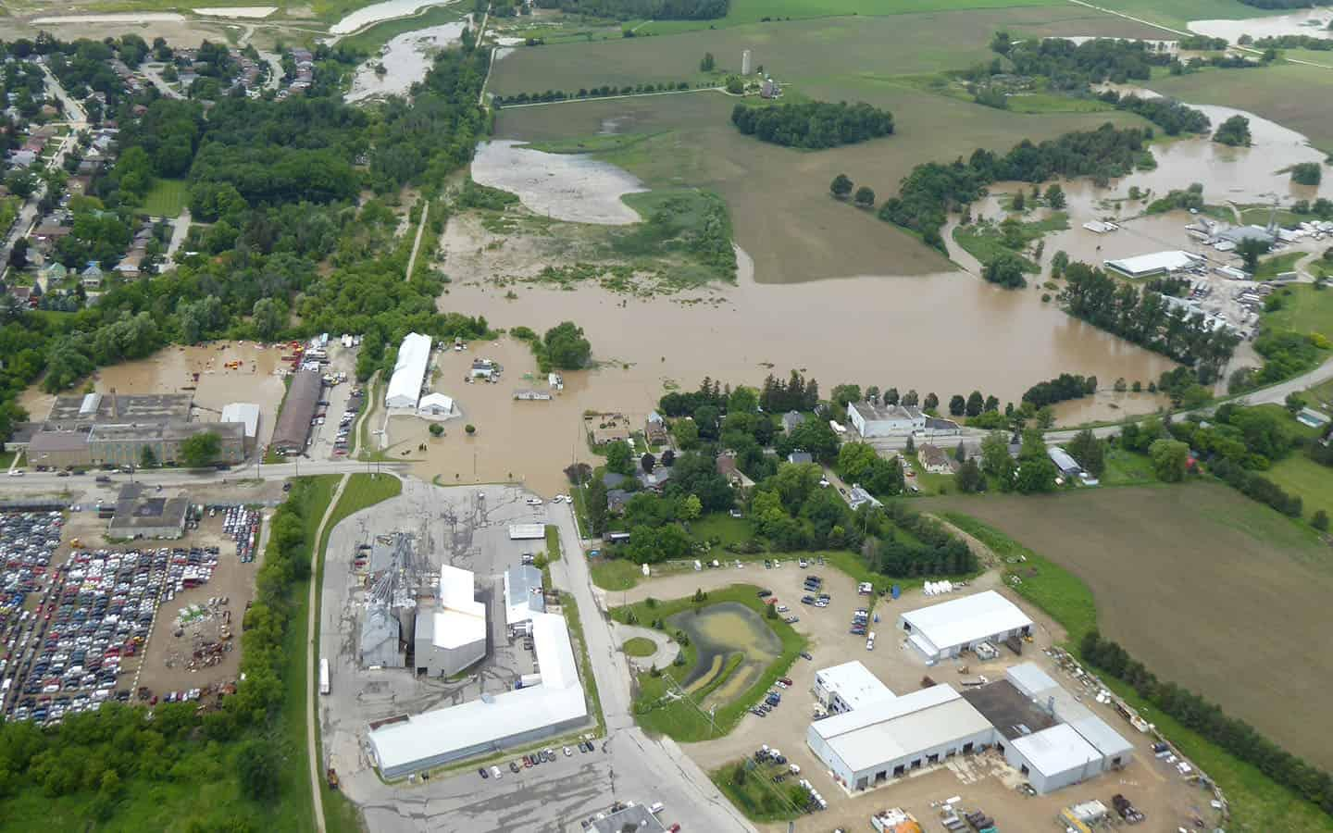](https://www.observerxtra.com/were-not-preparing-fast-enough-for-increased-flood-risk/)

## Iot based Flood monitoring and early warning system

***INTRODUCTION:***

Natural disasters like floods can wreak havoc on a large area and seriously endanger lives as well as property. Due to urbanization and climate change, floods have become more frequent and intense in recent years. The adoption of an Internet of Things (IoT)-based flood monitoring and early warning system has become essential to reducing the effects of floods and giving timely alerts to areas at danger.

The Internet of Things (IoT) is a technological paradigm that allows a vast array of physical objects and sensors to be connected to the internet so they can exchange, send, and gather data in real time. IoT provides communities, authorities, and individuals with actionable information to enable them to take preventive steps and make educated decisions in the face of imminent floods through the application of flood monitoring and early warning systems.

***CIRCUIT DIAGRAM:***

There are many different elements and factors to take into account while designing a flood monitoring and early warning system. Here are some basic design methods to get you going.

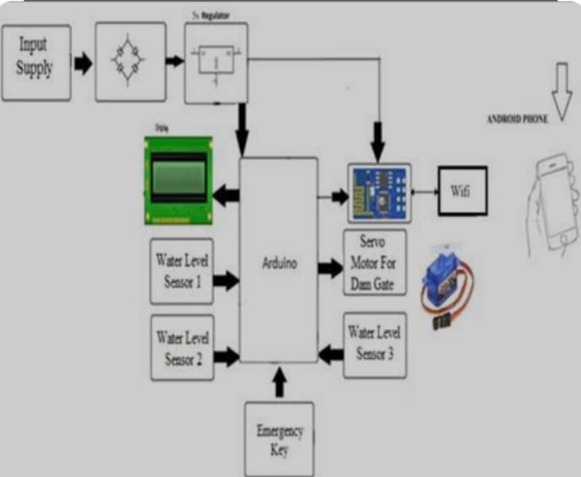

***COMPONENTS:***

ESP8266 Node MCU

Ultrasonic sensor

myDevices Cayenne

LEDs

Bread broad

Jumpers

Ultrasonic HC-SR04 wiring to ESP8266

Ultrasonic HC-SR04 ESP8266

Vcc Pin Vin Pin

Trig Pin D1 (GPIO 5)

Echo Pin D2 (GPIO 4)

GND Pin GND

***DEVICE SETUP:***

Developing a complete IoT-based flood monitoring and early warning system is a complex project that involves hardware, software, and network components.

***HARDWARE SETUP:***

Acquire appropriate flood monitoring sensors (e.g., water level sensors, ultrasonic sensor,rain gauges).

Connect these sensors to a microcontroller or single-board computer (e.g., Raspberry Pi or Arduino) that can interface with the sensors and connect to the internet.

***DATA COLLECTION:***

Write code on the microcontroller to read data from the sensors.

Use Python libraries like Adafruit_IO, MQTT, or HTTP to send this data to a central IoT platform or server.

***IOT PLATFORM:***

Set up an IoT platform (e.g., AWS IoT, Azure IoT, Google Cloud IoT, or a custom server).

Create an IoT device registry and configure device connections.

***PYTHON CODE:***

**import time**

**import random**

**import requests**

**# Simulate a flood sensor (replace with real sensor data)**

**def read_flood_sensor():**

**# Simulate a random water level between 0 and 100**

**return random.randint(0, 100)**

**# Replace with actual endpoint for sending alerts**

**ALERT_API_ENDPOINT = "https://your-alert-api.com/alert"**

**# Define a threshold for flood alert**

**FLOOD_ALERT_THRESHOLD = 80**

**while True:**

**# Read data from the flood sensor**

**water_level = read_flood_sensor()**

**if water_level >= FLOOD_ALERT_THRESHOLD:**

**# Send an alert to the IoT platform or external service**

**alert_data = {**

**"timestamp": time.time(),**

**"water_level": water_level,**

**"message": "Flood Alert! Water level is critical."**

**}**

**response = requests.post(ALERT_API_ENDPOINT, json=alert_data)**

**if response.status_code == 200:**

**print("Alert sent successfully.")**

**else:**

**print("Failed to send alert.")**

**# Delay between sensor readings (adjust as needed)**

**time.sleep(60) # Read sensor data every minute**

***REMOTE MONITORING:***

Ensure that the system can be monitored remotely and can be accessed through the internet.

***POWER AND CONNECTIVITY:***

Make sure the hardware components have reliable power sources and internet connectivity, especially in remote areas prone to floods.

***TESTING AND CALIBRATION:***

Thoroughly test the system under different weather conditions.

Calibrate sensors to provide accurate data.

This script simulates a flood sensor and sends an alert if the water level exceeds a predefined threshold. You need to replace the sensor simulation with real sensor data and configure the ALERT_API_ENDPOINT to send alerts to your IoT platform or system. Also, consider adding GPS location data to your alerts and implementing a mechanism for real-time monitoring.

***DEVELOPING PLATFORM:***

For a flood monitoring and early warning system web development, you'd want a robusttech stack. Consider using geospatial tools like GIS for mapping, real-time dataprocessing with languages like Python or Node.js, and databases for efficient datastorage. Integrating weather APIs can enhance predictive capabilities, and a user- friendly front end ensures accessibility. Always prioritize scalability and reliability in such critical systems.

***HTML Code:***

<!DOCTYPE html>

<html lang="en">

<head>

<meta charset="UTF-8">

<meta name="viewport" content="width=device-width, initial-scale=1.0">

<title>Flood Monitoring System</title>

<!-- Add your CSS links and stylesheets here →

</head>

<body>

<header>

<h1>Flood Monitoring System</h1>

</header>

<section>

<h2>Real-time Data</h2>

<!-- Display real-time data here →

</section>

<section>

<h2>Warnings and Alerts</h2>

<!-- Display warnings and alerts here →

</section>

<footer>

<p>&copy; 2023 Flood Monitoring System</p>

</footer>

<!-- Add your JavaScript scripts here for dynamic functionality →

</body>

</html>

***1.FIRST-END USER INTERFACE:***

Use HTML, CSS, and JavaScript to create a web-based user interface. Popular front-end frameworks or libraries like Angular, Vue.js, or React can be used for this.

***2. VISUALIZATION OF REAL-TIME DATA:***

To display sensor data in real-time, such as temperature, humidity, water level, etc., integrate a charting library such as Chart.js or D3.js.

***3. DEVICE INTEGRATION FOR IOT:***

Using IoT protocols like MQTT, CoAP, or HTTP, connect IoT sensors to your platform. To communicate with these sensors, you might require a microcontroller such as an Arduino or Raspberry Pi.

***4. REVERSE SERVER:***

To manage data processing, storage, and communication with IoT devices, set up a backend server using Node.js or any other server-side technology.

***5.DATABASE:***

Select a database system (such as PostgreSQL, MySQL, or MongoDB) to hold flood warning data and previous sensor data.

***6. INSTANTANEOUS COMMUNICATION:***

For real-time communication between the server and the front-end, use WebSocket or Server-Sent Events (SSE).

***7. WARNING SYSTEM FOR FLOODS:***

Create an algorithm to evaluate sensor data and send out flood alerts based on predetermined thresholds, or incorporate a third-party service.

***8.USER NOTICES:***

Establish a notification system to notify users of flood warnings by email, SMS, or in-app notifications.

***9.SECURITY:***

By using appropriate authorization and authentication procedures and encrypting data transferred between devices and the server, you can be sure that your system is safe.

***10. CHECKING AND OBSERVING:***

Make sure your system is reliable by giving it a comprehensive test, and set up monitoring to find and fix problems.

***BENEFITS:***

***Early And Accurate Warnings:*** Internet of Things technology makes sure that alerts are sent out as soon as a possible flood threat is identified, speeding up reaction times and potentially saving lives.

***DATA-DRIVEN DECISION-MAKING:*** Having access to up-to-date information helps decision-makers allocate resources and manage disasters more effectively.

***REMOTE MONITORING:*** The Internet of Things makes it possible to monitor flood-prone areas remotely, negating the need for people to remain present in hazardous places all the time.

***SCALABILITY***: IoT-based solutions are easily scalable and adaptable to monitor and reduce the danger of flooding in various geographic areas.

***COMMUNITY INVOLVEMENT***: Providing communities with up-to-date information encourages a pro-active strategy for flood response and preparation.

***DEMERITS:***

***RELIABILITY:*** IoT systems are susceptible to technical problems that could result in erroneous data or system downtime, such as sensor malfunctions, connectivity problems, or power outages.

***DATA SECURITY***: The integrity of flood monitoring data and early alerts may be jeopardized by IoT devices' susceptibility to hacking and data breaches.

***COST:*** The deployment and upkeep of an Internet of Things system can be expensive, requiring payments for sensors, communication infrastructure, and continuous maintenance.

***COVERAGE:*** The density and dispersion of sensors determine how effective IoT-based solutions are. Flood alerts may be incomplete or delayed as a result of coverage gaps.

***DEPENDENCY ON INTERNET CONNECTIVITY***: A reliable internet connection is essential to the system's operation. The system might not work at its best in places with bad connectivity.

***CONCLUSION:***

In conclusion, a technological innovation that is essential to disaster resilience is an Internet of Things-based flood monitoring and early warning system. Through the integration of sensors, IoT devices, and data analysis, these systems provide informed decision-making and early alarms, thereby mitigating the disastrous effects of floods. This project is evidence of how technology can improve our capacity to successfully respond to natural disasters.